A Filterbank-based Representation for Classification and Matching of Fingerprints

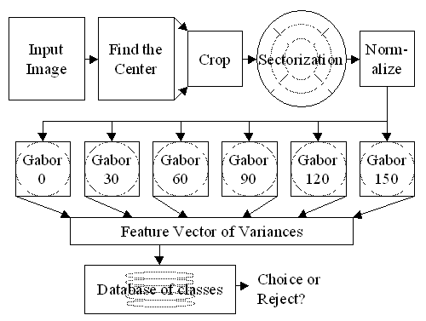

Figure 1 Description of the algorithm

Step | Corresponding M-function
Find the center (core point localization) | Supercore.m
Crop | Cropping.m
Sectorization | Whichsector.m
Normalize | Sector_norm.m
Filter-bank (8 filters) | Gabor2d_sub.m
Feature Vector of Variances | Sector_norm.m
Choice/Reject or add to DataBase | Fprec.m (main file)

Up to now, when a new fingerprint image is added to database, the FingerCode was calculated two times: one time for input image and a second time for the image rotated of a proper angle (22.5/2 degrees) in order to make the process rotation-invariant (see the cited reference for more details). The image was rotated using the Matlab function imrotate. This procedure can introduce noise. To avoid this behavior we calculated the FingerCode associated to the rotated image in this way: we rotate sectorization and the orientation of Gabor filters of filter-bank of the same angle (22.5/2 degree). This is equivalent to consider as filter-bank input a rotated image.

When a new fingerprint image is added to database, only one core point is found. On the other side, when an input image is selected for fingerprint matching, a list of candidates for core point is found and the matching is performed for each of them. At last only the candidate with the smallest distance is considered. For example , in database I have 3 images Img1, Img2 and Img3. Each of them is characterized only by one core point, so I will have 3 core points, each of them associated to an image present in database. If I select an image for fingerprint matching (let it be ImgNew) I found for it a certain number of core point (let it N). For each of these N core points (candidates) I will find the nearest fingerprint image present in database. At last I will obtain N distances (as the number of core points candidates): I say that the recognized image is the image with the nearest distance I have obtained (this distance is associated to one of the initial N core points candidates of ImgNew). This approach is very similar to the algorithm discussed in

Erian Bezhani, Dequn Sun, Jean-Luc Nagel, and Sergio Carrato, "Optimized filterbank fingerprint recognition", Proc. SPIE Intern. Symp. Electronic Imaging 2003, 20-24 Jan. 2003, Santa Clara, California.

The pixel-wise orientation field estimation (the M-function is orientation_image_luigiopt.m) is greatly accelerated reusing previous sum computations. The sum of elements of a block centered at pixel (I,J) can be used for the computation of the sum of block elements centered at pixel (I,J+1). This can be performed in the following way:
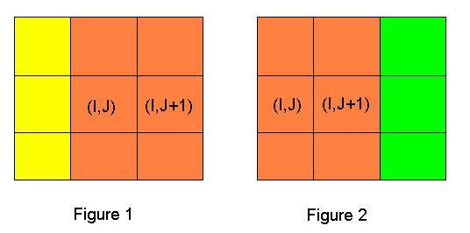

Once the sum of values centered at pixel (I, J) has been calculated (sum of yellow pixels and orange pixels of Figure 1), in order to calculate the sum centered at pixel (I, J+1) we simply subtract from the previous sum the yellow area and add the green area (see Figure 2): in this way it is possible to save a lot of computation. In other words
SUM (I, J) = yellow + orange
SUM (I, J+1) = SUM (I, J) – yellow + green.

For more details concerning the implementation of this algorithm please visit
http://www.ece.cmu.edu/~ee551/Old_projects/projects/s99_19/finalreport.html

The function Supercore.m is discussed in detail in the document corepoint.doc

References

A. K. Jain, S. Prabhakar, and S. Pankanti, "A Filterbank-based Representation for Classification and Matching of Fingerprints", International Joint Conference on Neural Networks (IJCNN), pp. 3284-3285, Washington DC, July 10-16, 1999.
http://www.cse.msu.edu/~prabhaka/publications.html

